6. Market research

Due to the steady population growth over the last 20 years, traffic volumes have increased along all classes of UK roads (Road Traffic Estimates: Great Britain 2014 (R), 2014). This has resulted in an increase in traffic congestion and management problems. Traffic jams are far more common in this day, especially involving vans (Road Traffic Estimates: Great Britain 2014 (R), 2014). These types of problems are, present in the UK, are not just limited to motor vehicles.

6.1. Demographics

Over time there has been a substantial change in the age groups that are involving themselves in vehicle transportation. More specifically, the number of young people with full driver licenses has decreased from 44 % in 1995/1997 to 31% I 2013(Road Traffic Estimates: Great Britain 2014 (R), 2014).

6.2. Market Value

Through time the definition of what is a “smart city” has changed to include many things, however one thing has remained the same – being part of “smart cities” means “utilizing information and communications technology (ICT) and the Internet to address urban challenges.” Cisco, (Mitchell et al., 2013). Currently it is estimated that the population in urban areas grows by nearly 60 million every year and as a result more than 60 % of the population will live in cities by 2050, which will be expressed in massive resource consumption Cisco, (Mitchell et al., 2013).

The market for IoT and IoE based solutions can be generally divided into 5 smaller subsections:

- Smart Energy Management
- Smart Water Management
- Smart Transport Management
- Smart Waste Management
- Assisted Living
Smart Energy Management

This subsection is one that demonstrates a very wide range of technology, services and products which leads to specific specialized domains for customers to choose from based on their needs. It is estimated to grow to a value of $ 500 billion by 2030 (Department for Business, Innovation and Skills, 2013).

Trends

- Smart metering/AMI – the meters of today can provide “real time energy use data, power outage detection, dynamic pricing, switching between suppliers, and a Home Area Network interface.” .
- Smart appliances – growth in this market provides continued opportunity. Sales are projected to exceed 24 million by 2017. Manufacturers have yet to capitalize on this market in part to the results of a survey which showed that “consumers have shown no willingness to buy smart appliance outside their 10-year average replacement cycle, unless they are available at the right price and deliver tangible energy savings.”

Information adapted from Department for Business, Innovation and Skills, 2013 page 26 – 27.

Smart Water Management

A market of considerable size with an estimated growth of 20% annually by 2020 and with an excess of $22.2 billion by 2020 (excess includes needed innovation and implementation of smart technologies) (Department for Business, Innovation and Skills, 2013).

Trends

The market is generally classified as conservative and risk averse due to strict regulations hindering innovation. The adoption of smart technologies in this market has been led by countries like Australia, Israel and Singapore while the UK is lagging in the adoption process. While the opportunities for investment are on a increase investors are not confident in this market due to the long development cycles and heavy capital requirements that may not pay off.

Information adapted from Department for Business, Innovation and Skills, 2013 page 52 – 56.

Smart Transport Management

This market has presented huge increase with an estimate of a 20+% increase per annum and an excess of $100 billion by 2018 (excess includes needed innovation and implementation of smart technologies) (Department for Business, Innovation and Skills, 2013).

Trends

The market focuses heavily on Transport Information Application in order to reduce congestions and emissions, improve quality of life, safety and optimize the flow of traffic. Some implementations include:

- GIS/traffic management service application model integration and convergence;
- GIS based mass traffic information management engine
- GIS/traffic management service application model integration and convergence
- Traffic comprehensive information resources integration
- Traffic data center and traffic flow data survey and analysis
- Traffic data collection, statistical analysis and presentation
2. Intelligent traffic features (to reduce congestion, improve quality of life, reduce emission from traffic, improve safety and optimize traffic flow)

- Dynamic traffic information acquisition, integration, processing, forecast and
- distribution
- Electronic toll collection
- Intelligent parking guidance system
- Vehicle licence plate automatic identification
- Traffic event automatic detection
- GPS monitoring/dispatching and information service

Information adapted from Department for Business, Innovation and Skills, 2013 page 83 – 84.

Smart Waste Management

On a global scale, it was estimated that the market is worth a total of $ 475 billion in 2015, however a concrete value could not be estimated due to the nascent nature of the sector (Department for Business, Innovation and Skills, 2013).

Trends

The main focus of this sub-market is efficiency, enhancement of waste collection and separation, cost reduction and improved recycling. These act as the main drivers of change with some of the deployed technologies reflecting that:
- Smart Public Realm Bins – self-contained, solar powered trash compactors
- Refuse Collection Vehicle GPS Tracking – information gathered is used to increase operational efficiency of refuse collection vehicles.

Information adapted from Department for Business, Innovation and Skills, 2013 page 107 – 108.

Assisted Living

The market growth is on a continuous increase, in large part dictated by the willingness of households to adopt smart technology. Of particular note is the rate of acceptance in community centers and private households. Smart technology in community centers was valued at $ 115.5 million in 2009 with a annual growth of 20.2% until 2015 and private household services at $ 39.4 million in 2009 and with a 28.5% increase until 2015 (Department for Business, Innovation and Skills, 2013).

Trends

The primary drivers in this market are demographics, with the largest problem being the aging population, economic and social, the demand for care technology for an aging population increases (Department for Business, Innovation and Skills, 2013).

- Market Driven Growth - Increased private participation will lead to higher competition, and private sector investment will drive the growth instead of government-funded projects.
- Private funding - Will rapidly increase and overtake the government funds.
- Diversification - Strong market participants will expand into other lucrative regions, and there will be large-scale plans under execution.
- Interoperability - Equipment is likely to become globally interoperable and will use open platform software to enhance connectivity.
- Shift in Demands - There will be a vast expansion in product portfolio and the aged population are likely to change their demands. There will be specific suppliers for the variety of equipment.

Information adapted from Department for Business, Innovation and Skills, 2013 page 106.

6.3. Target Market

The primary, income contributors customers will be data analysis companies and local business owners. Value to these customers will be provided through the sale of licenses for data sets and sales of raw user data, contributed by users, in relation to their business goals.

6.4. Market Need

CHLOE

6.5. Competition

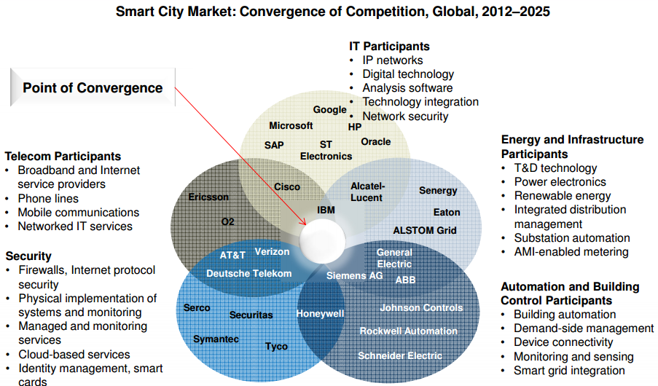
Source: Frost and Sullivan ‘Strategic Opportunity Analysis of the Global Smart City Market’

The competitive advantage provided by our product is the merging datasets from public and private domains in order to provide layered information to assist with decision making for corporate endeavors, by providing niche data relevant to business goals, and individual users by providing specific data to create a bespoke map based on location.

7. Unique Selling Point

CHLOE

8. Additional marketing materials

One of the main objectives of our project is to improve the quality of life of each individual by providing them with the tools to help in location planing to achieve business goals. In order to achieve this goal we need to look at what a “smart city” offers.

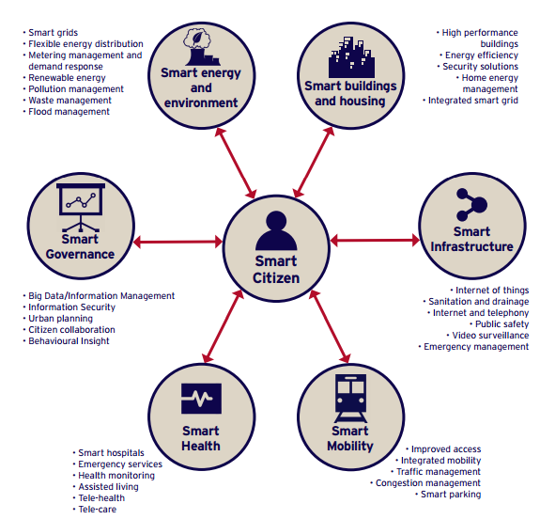

Source: HM Government (2016) ‘Smart cities Pitchbook’

Cities are real-time systems, and a “smart city” is made up of several smart systems. An intelligent city will have smart physical, social, institutional and economic infrastructure in a sustainable environment, with its citizens at the center of these systems. We focus our attention on Smart Governance, Smart Infrastructure and Smart Mobility by merging and layering data from private and public domains.

All of this data can be utilized by businesses in order to discover areas and markets in which they can position themselves. The largest benefactors from this are the small business owners which can use geolocation and population density data to make a model of trends on how potential consumers move and behave in their vicinity. This can help them determine what type of advertisements are most effective, what products to offer and if they need to reposition or refocus themselves in the market in order to achieve the highest level of consumer satisfaction, reputation boost and revenue increase.

References

Department for Business, Innovation and Skills. (2013) ‘The Smart City Market: Opportunities for the UK’. Available at: https://www.gov.uk/government/uploads/system/uploads/attachment_data/file/249423/bis-13-1217-smart-city-market-opportunties-uk.pdf (Accessed: 20 October 2016).

Frost and Sullivan ‘Strategic Opportunity Analysis of the Global Smart City Market’, Available at: http://www.egr.msu.edu/~aesc310-web/resources/SmartCities/Smart%20City%20Market%20Report%202.pdf (Accessed: 20 October 2016)

HM Government (2016) ‘Smart cities Pitchbook’. Available at: https://www.gov.uk/government/uploads/system/uploads/attachment_data/file/526238/Smart_Cities_Pitchbook.pdf (Accessed: 21 October 2016).

Mitchell, S., Villa, N., Stewart-Weeks, V. and Lange, A. (2013) ‘The Internet of Everything for Cities Connecting People, Process, Data, and Things To Improve the “Livability” of Cities and Communities’, Available at:https://www.cisco.com/c/dam/en_us/solutions/industries/docs/gov/everything-for-cities.pdf (Accessed: 20 October 2016) Cisco, .

‘Road Traffic Estimates: Great Britain 2014 (R)’ (2014) Department for Transport, Available at: https://www.gov.uk/government/uploads/system/uploads/attachment_data/file/487689/annual-road-traffic-estimates-2014.pdf (Accessed: 20 October 2016).

